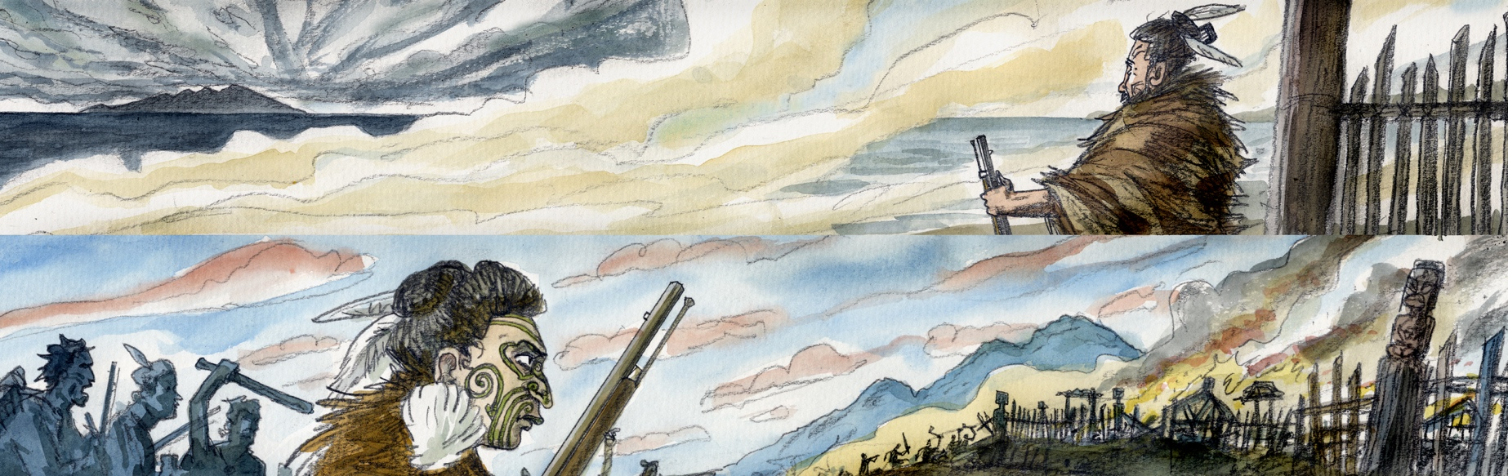

Ngā Pakanga o Ngāti Toarangatira me Kāi Tahu – Kaiapohia
He mea taka ēnei mahi i te wā i tino runga rawa te mana whenua o te Māori. I āhukahuka te Māori i ngā huanga ka puta i te tauhokohoko me te whakawhanaunga ki te Pākehā, ina koa te awe o te pū i ngā kawe ā-riri.

Tirohanga Whānui
Ko tā ēnei tuhipoka he tautoko i te ataata me te kōrero mō te tīmatanga o ngā pākanga i waenga i a Kāi Tahu me Ngāti Toarangatira i te ngahuru tau o 1820. Ka whakarato i:
- Ētahi hononga ki ngā wāhanga ako o Ngā Tikanga ā-Iwi me Te Reo Māori (tau 9–10).
- Ētahi huatau mō ngā ngohe ka ahu mai i te ataata me te kōrero.
- Ētahi anō rauemi, hononga hoki ka whai tikanga pea.

Ngā hononga ki ngā wāhanga ako o Te Marautanga o Aotearoa
Tikanga ā-Iwi
Te Ao Hurihuri
5.1 Ka whakamārama i te whakaawenga o ngā tūāhua o mua i ngā hononga i roto, i waenga hoki, i te rōpū, me te haere tonu o ēnei whakaawenga.
5.2 Ka whakamārama i ngā whakapono me ngā mahi a ngā tāngata o mua kua waihanga i te porihanga o Aotearoa.

He mahi whakaea, he huarahi ako
E aro ana ēnei ngohe ki te ataata me te kōrero. Ka āhei te whakamahi hei ngohe ā-akomanga, ā-rōpū iti, takitahi rānei.
He huatau noa iho ēnei ngohe, ka āhei te urutau kia hāngai ki ō ākonga. Hei kōwhiringa kē atu, hei ngohe whakawhānui rānei, whakatewhatewhatia ētahi mahi i taka i taua wā anō i tōu rohe.

He Whakapapa
- Rangahautia te whakapapa o tētahi tangata mana nui o Kāi Tahu, o Ngāti Toarangatira rānei i whai wāhi ki tēnei wāhanga hītori. Kua kite mōhiohio koe mō ā rātou uri? Whakakotahitia te whakapapa me ngā huānga ataata ki te tohu i taua tangata me te hanga i tētahi whakaaturanga ataata, hei tauira, he pānui, he whakaaturanga PanaHiko rānei.

- Tūhuratia tōu ake whakapapa me te rangahau i tētahi tupuna e ora ana i te wā tonu i mahi aua mahi. He aha ngā mahi hira i te rohe, i te ora rānei o tō tupuna i taua wā? He aha ngā mea e aweawe ana i tō rātou āhua noho i taua wā?

He Whenua
- Kōwhiria tētahi o ngā tauwāhi i kōrerotia i roto i te kōrero me te kimi mōhiohio anō mō taua tauwāhi. Rangahautia:
  - Ko wai mā ngā iwi, hapū, tāngata mana nui rānei e whai pānga ana ki taua wāhi?
  - He aha ngā mahi hira i mahia i konei? He aha ētahi atu mahi, i tua atu i ērā e arohia ai i tēnei houanga, i tūpono i konei?
  - Ki ō whakaaro, he aha tēnei wāhi i pai ai hei wāhi noho?
  - I pēhea ngā iwi i urutau ai ki te horonuku?
  - He aha te wāhi o te horonuku ki tēnei mahi hītori?
- Hangaia he tauira ahutoru o te wāhi nāu i kōwhiri.
- Hangaia he whakaaturanga rongo-ataata mō tō wāhi—he aha ngā āhuahira e toe tonu ana i tēnei rā?
- Rangahautia he tauwāhi i tō takiwā.

Whakaarohia
- Tonoa ngā ākonga kia whai whakaaro ki ēnei:
“He tao rākau e taea te karo, he tao kupu tē taea te karo.”
- Ōhia manomanotia hei akomanga tēnei whakataukī. Mō te taha ki tēnei kōrero o mua matapakitia taua whakataukī. Kōrerorerotia ētahi tauira whaiaro, ā-rohe, ā-ao hoki nō nāianei.
- Matapakitia ngā mutunga iho o te "kīmōkai", arā, ko te whakatūtūā, te hahani rānei i roto i tēnei kōrero o mua.
- Hei rōpū iti ka whiriwhiri ngā ākonga i ngā mahi ka whakamahia pea hei whakatau raruraru ahakoa whaiaro, ā-rohe, ā-ao rānei.
- Ka whakaputa ariā ngā ākonga i ō rātou rōpū iti mō ngā āhua i whakarerekētia ai pea ngā mahi i roto i tēnei kōrero nā tētahi mahi whakatau raruraru kē. Hei tauira, tērā e pakanga a Kāi Tahu me Ngāti Toarangatira mō te tekau tau i whai atu, kāore rānei? Kua huri pēheatia ngā mahi o mua nā te whakahangahanga?
- Mā te mahi i roto i ngā rōpū o ngā ākonga 4–6, ka hanga rātou i tētahi tikanga whakatau raruraru kē mā Kāi Tahu me Ngāti Toarangatira, me te whakaatu ki te akomanga.
- Mā ngā rōpū e tiritiri:
- ngā pūtake i kōwhiri rātou i tō rātou tikanga whakatau raruraru
- he aha i whaitake ai pea ki a rātou taua tikanga whakatau raruraru
- ngā āhua i whakarerekētia ai pea nga mahi o mua e taua tikanga whakatau raruraru.

Tirohanga
- Hei akomanga, matapakitia te tirohanga o te kaituhi i roto i tēnei kōrero hītori. E whakaahua ana te kaituhi hei tangata nō Kāi Tahu i ngā mahi i mahia. Ka pēhea a Ngāti Toarangatira e whakaahua ai pea i aua mahi?
- Ka mahi takirua ngā ākonga, ka kōwhiri i tētahi aronga o te kōrero me te kōrero anō mā te tirohanga a tētahi nō Ngāti Toarangatira.
Ka tere rangahautia e ngā ākonga te hītori o Ngāti Toarangatira i te tōmuatanga o ngā tau 1800 kia mōhio ai ki te tirohanga pea o taua iwi. Hei tauira, me rapu i a Ngāti Toarangatira i te paetukutuku Te Ara.

